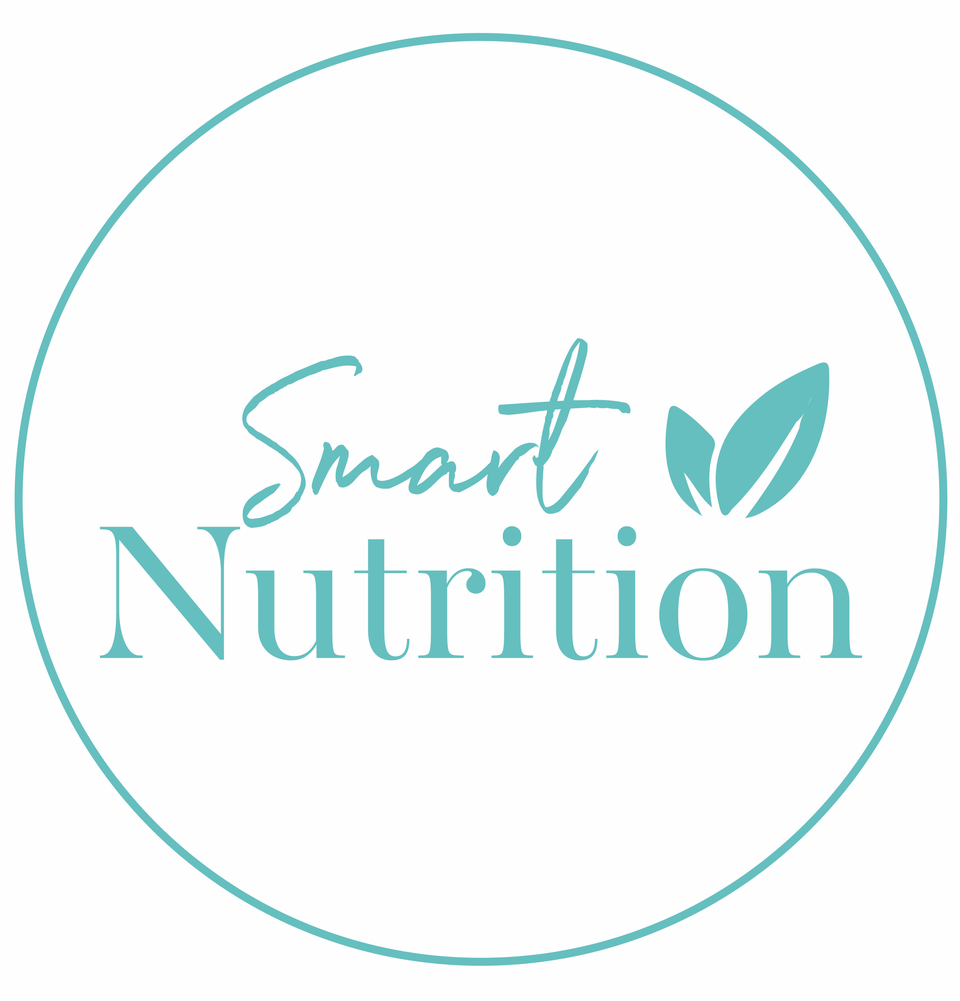
Food & Symptom Diary

- Please complete the following food diary for 5 consecutive days including 2 weekend days
- Do not change your eating patterns or portion sizes. The idea is to get an accurate picture of your usual intake
- For any homemade meals please include recipes where possible – the more accurate you are the more accurate we can be in providing dietary recommendations
- Include all condiments/fats/oils/sugar added to foods e.g butter, salt, oil, mayonnaise, salad dressing
- Include all drinks e.g water, tea, milk, juice, alcohol, sports drinks
- If you have problems with bloating, heartburn (reflux), diarrhoea, constipation, abdominal pain, nausea, headaches, fatigue, skin rashes, food cravings or any other symptoms that you think may be food related please record these in the symptoms column

See example below
Time | Food/drink consumed | Symptoms
7 am  10 am  12.30 pm | ¾ cup Light and Tasty cereal with ½ cup light blue milk + ½ a cup blueberries  1 x 150 g pottle Fresh and Fruity strawberry yoghurt  1 x 140 g Cadbury Dairy Milk Chocolate bar  2 x slices Vogel’s sandwich sliced bread with 2 tablespoons Lisa’s original hummus and ½ a tomato  10 grapes | Craving something sweet  Bloated

Time | Food/drink consumed | Symptoms
Time | Food/drink consumed | Symptoms
Time | Food/drink consumed | Symptoms
Time | Food/drink consumed | Symptoms
Time | Food/drink consumed | Symptoms
Time | Food/drink consumed | Symptoms
Time | Food/drink consumed | Symptoms

